

Is The Home Depot Fairly Valued? A Fundamental Analysis.
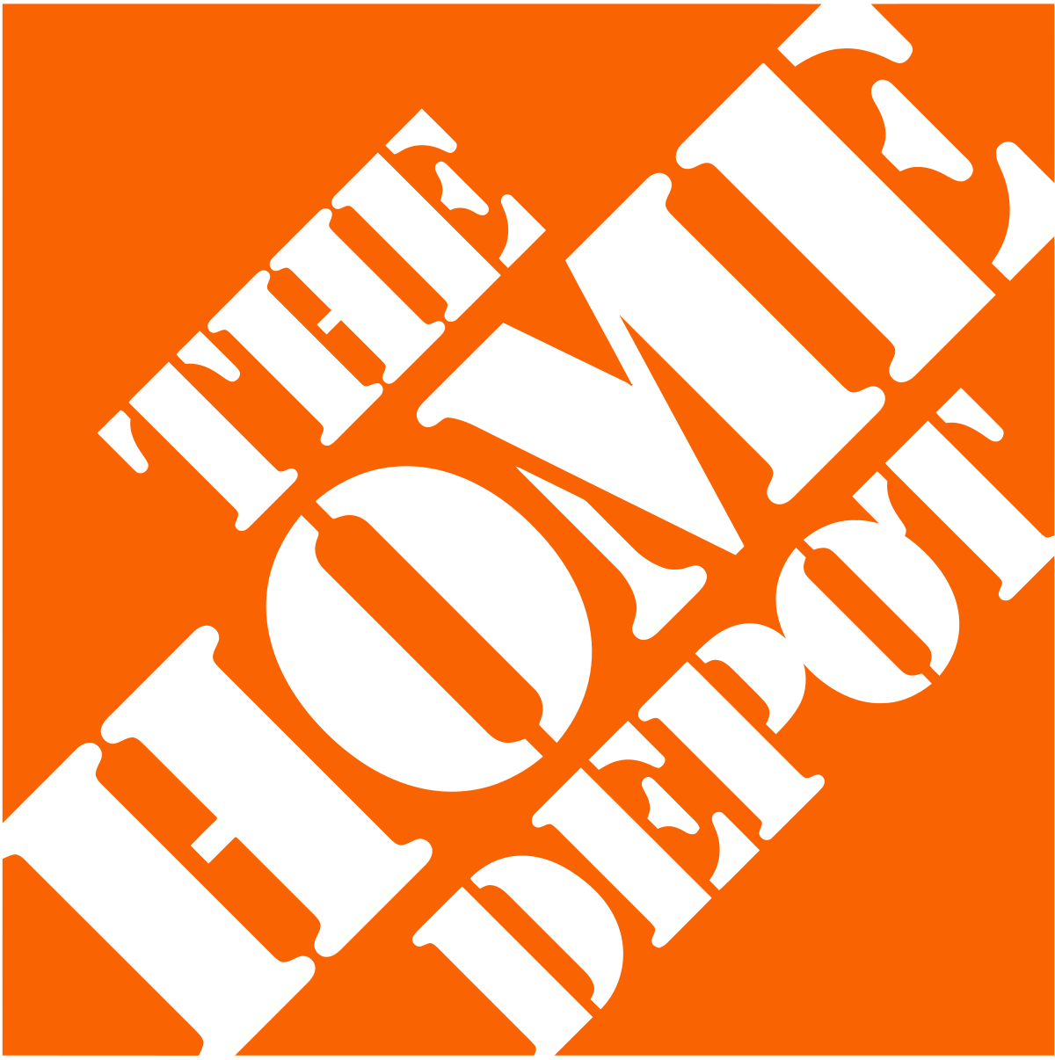

Aman Aman
March 28,2025
Table of Contents

- Introduction. . . . . . . . . . . . . . . . . .. . . . . . . . . . . . . . . . . . . . . . . . . . . . . . . . . . . . . . . . . .3

- About Home depot. . . . . . . . . . . . . . . . . .. . . . . . . . . . . . . . . . . . . . . . . . . . . . . . . . . . . . 3

- Constant-Growth model. . . . . . . . . . . . . . . . . . . . . . . . . . . . . . . . . . . . . . . . . . . . . . . . . 3
  - Data. . . . . . . . . . . . . . .. . . . . . . . . . . . . . . . . . . . . . . . . . . . . . . . . . . . . . . . . . . . . 4
  - Methodology and Empirical Results. . . . . . . . . . . . . . . . . . . . . . . . . . . . . . . . . .6
  - Recommendation. . . . . . . . . . . . . . . . . . . . . . . . . . . . . . . . . . . . . . . . . . . . . . . . .9

- P/E Ratio. . . . . . . . . . . . . . . . . . . . . . . . . . . . . . . . . . . . . . . . . . . . . . . . . . . . . . . . . . . . . . . 9
  - Data. . . . . . . . . . . . . . .. . . . . . . . . . . . . . . . . . . . . . . . . . . . . . . . . . . . . . . . . . . . . 9
  - Methodology and Empirical Results. . . . . . . . . . . . . . . . . . . . . . . . . . . . . . . . . .9
  - Recommendation. . . . . . . . . . . . . . . . . . . . . . . . . . . . . . . . . . . . . . . . . . . . . . . . 10

- Conclusion. . . . . . . . . . . . . . . . . . . . . . . . . . . . . . . . . . . . . . . . . . . . . . . . . . . . . . . . . . . .10

- References. . . . . . . . . . . . . . . . . . . . . . . . . . . . . . . . . . . . . . . . . . . . . . . . . . . . . . . . . . . . 11

Introduction
As an asset manager, the job is to give the buying or selling recommendation for a stock, In this I will be working on The Home Depot, Inc. stock price , by using mainly two methods
- Constant Growth model: Also known as Gordon Growth model- GGM) is a valuation method used to determine the intrinsic value of a stock by assuming that dividends grow at a constant rate indefinitely. It is a simplified version of the Dividend Discount Model (DDM) and is primarily used for valuing mature companies with stable dividend growth. The model calculates a stock's present value based on its expected future dividends and the required rate of return.

- P/E Ratio: This approach involves comparing The Home Depot's valuation multiples, such as the Price-to-Earnings (P/E) ratio, with industry peers to assess whether the stock is overvalued or undervalued. Relative valuation provides insights based on market-driven benchmarks.

Description Home Depot

The Home Depot is the world's largest home improvement chain and one of the largest retailers in the US. The company operates more than 2,335 stores in North America. It targets the do-it-yourself (DIY), Do-It-For-Me (DIFM), and professional markets with its selection of up to 40,000 items, including building materials, home improvement products, lawn and garden products, décor products, and facilities maintenance, repair, and operations products. The Home Depot also home improvement installation services and tool and equipment rental. It conducts e-commerce operations through its websites (including homedepot.com, homedepot.ca, and homedepot.com.mx) and mobile apps. More than 90% of its revenue is generated within the US.

Operations
The Home Depot store stocks approximately 30,000 to 40,000 items, including both national brand names and proprietary products. Its online product offerings complement its stores by serving as an extended aisle, and it offers a significantly broader product assortment through its websites and mobile applications. The Home Depot has three major product lines: Building Materials (accounts for more than 35% of its revenue), Decor (nearly 35%), and Hardlines (about 30%).
Its Building Materials covers electrical, lighting, lumber, millwork, plumbing, and building materials departments; Decor includes appliances, flooring, kitchen and bath, paint, and décor/storage departments; and Hardlines consist of hardware, indoor garden, outdoor garden, and tools departments. Its top-selling categories include indoor garden, appliances, electrical/lighting, lumber, kitchen and bath, paint, plumbing, tools, and outdoor garden.
Products account for some 95% of the company's revenue, with services such as installation and equipment rental contributing to the rest.

Geographic Reach
Headquartered in Atlanta, Georgia, Home Depot boasts about 2,015 stores across all 50 US states, Puerto Rico, Guam, and the Virgin Islands. Its top markets include California, Florida, Texas, and New York, which make up about 35% of its total locations. It also operates some 320 stores in Canada and Mexico.
The company generates more than 90% of its revenue in the US.

Constant-Growth Model

Data
The data considered for this report is as given below
- Historical data:
This data set contains the daily closing prices of Home Depot Inc. and the S&P 500 index over the past seven years. Based on these prices, the daily returns have been calculated for each day to analyze the stock's performance and its correlation with the broader market.
The last closing price in the dataset for HD ON 13th march was 347.25 and for S&P500 on the same date was 5521.52
Source: Bloomberg Terminal
- Dividends and Growth Rate:
The data set consists of the dividend paid by the company each quarter from Feb-2018 to Dec-2024
Source: Bloomberg Terminal

- Risk-Free Rate:
The risk-free rate is the return on an investment with zero risk of financial loss

The current risk-free rate is 4.37%
Source: Yahoo finance

- Total debt:
This is the sum of the company’s short-term and long-term borrowings, which includes loans and bonds. The data taken is from 2021-2024

Source: Bloomberg Terminal

- Total Equity:
This is the remaining of the shareholders after deducting total liabilities from total assets; represents ownership stake.

Source: Bloomberg Terminal

Total Assets:
This is the Total value of Everything a company owns, which also includes cash, investments, inventory and property.

Source: Bloomberg Terminal

Date | Total Debt | Total Equity | Total Asset | Leverage Ratio
31-Dec-21 | 43488000 | 33042000 | 76530000 | 0.568247746
31-Dec-22 | 46467000 | 29978000 | 76445000 | 0.60784878
31-Dec-23 | 50595000 | 21281000 | 71876000 | 0.703920641
31-Dec-24 | 52511000 | 18070000 | 70581000 | 0.743982091
Table 1:Leverage Ratio

Methodology and Empirical Results:

Assumptions of Constant-Growth Model:
The Constant-Growth Model based on several key assumptions like Stable business, Steady Growth of dividends and Stable Financial Leverage that hold true to provide reliable estimates.
- Stable Business:
Home Depot’s stability is driven by its strong brand reputation, market leadership as the largest home improvement retailer in the U.S., and a diverse product offering catering to both DIY customers and professionals. The company has adapted well to e-commerce trends and maintains strong financial health. Its customer-centric approach and resilience during economic downturns further solidify its stable business environment, making it a reliable candidate for the Gordon Growth Model.

- Steady Growth of Dividends:
The company has seen that there is a consistent growth of the dividends over the past few years, this is visible from the Figure 1, the data is taken from past 7 Years, The Home depot dividend has grown consistently. From $1 in Feb-18 to $2.25 in Nov-2024,

Figure 1 : Dividends
- Stable Financial Leverage:
As seen from the chart as well the leverage ratio is increasing over time, but still, it is not that of a change. Which is also visible in the Figure 2. So, we can consider this as a Stable Financial Leverage

Figure 2: Leverage Ratio 2021-2024

β: Beta was calculated with taking slope of daily return of stock price and daily return of market and to calculate beta we must calculate the daily return.
The slope formula is and the β calculated for this is 0.98121
=SLOPE(C3:C1762,F3:F1762)

market's expected return:
To estimate the market's expected return, i calculated the historical average return of a broad market index of S&P 500 over 7 years,
= (1+AVERAGE (F3:F1762))^252-1 (as this is daily data)
after calculation, its value came out to be r_{m} =12.569%.

Risk Free rate:
I use the 10-year U.S. Treasury bond yield as a proxy for the risk-free rate, which currently stands at r_{f} = 4.37%. This is because Treasury bonds are considered virtually risk-free due to the U.S. government's creditworthiness.

Required rate of return on a stock(E(r_{e})​):
To estimate the required rate of return on a stock, E(re), I used the Capital Asset Pricing Model (CAPM) formula
By plugging in the values for these variables, I estimated the expected return for the stock. if the beta came as 0.98121 and the expected market return is 12.569%, the calculation would give an expected return of 12.415%. This process allows me to estimate the required return based on both the stock's risk and the broader market conditions.
This is the Formula for this.
E(r_{e})​=r_{f}​+β_{i}​ x (r_{m}​− r_{f} ​)
r_{m}​: market return
r_{f:} risk free rate
E(r_{i}): Expected return of the market

dividend growth rate:
To calculate the dividend growth I took the data from past 3 years from 2022 to 2024 the formula was this. =(F8/F6)^(1/(E8-E6))-1 and the result was 8.82%.
Here F8 is dividend for 2024, F6 Dividend for 2022and E8 and E6 are 2024 and 2022 respectively.
Dividend payments in 2027
This is given by formula D₁ = D₀ X (1+g)^{t}
D₀ is the last dividend, and g is the growth rate of the model. BY putting the value of these as g =8.82% and D₀ = 9 and t =3 as we are calculating for 2027 3 years from 2024. I get the value for stock price in 2025 is $ 322.78

Recommendation for Constant-Growth model:
The stock of Home Depot closed at $351.15 on March 14, 2025. Compared to the 2025 intrinsic value of $322.79 estimated from constant-growth model, the stock is overvalued. Therefore, my recommendation for the stock of The home depot Inc. is "sell".

P/E Ratio:
The P/E Ratio—or “Price-Earnings Ratio”—is a common valuation multiple that compares the current stock price of a company to its earnings per share (EPS).
Simply put, the P/E ratio of a company measures the amount that investors in open markets are willing to pay for a dollar of the company’s net income as of the present date.

a) Data
This analysis uses Home Depot's P/E ratio from 2022 to the present to examine the company's valuation trends over a relevant period. The selected timeframe reflects the effects of market fluctuations, including the post-pandemic recovery and shifts in macroeconomic conditions like interest rates and inflation. This period provides a comprehensive view of how Home Depot’s stock price relative to earnings has evolved in response to both internal and external factors.

Source: Yfinance , Bloomberg Terminal

b) Methodology and Empirical Results
To estimate the intrinsic value of the company, the first step is to compute the average current P/E ratio based on historical data. Using the available monthly P/E data from January 2022 to March 2025, the average current P/E ratio is calculated as:
Using Excel's formula =AVERAGE(B2:B40), the average current P/E ratio is 21.57.

Earnings Estimates for 2026
The intrinsic value of the company is determined using the P/E valuation model:
Intrinsic Value=P/E Ratio× Earnings Estimate

The estimated earnings per share (EPS) for 2026 are provided as 15.06. This value is crucial for estimating the company's intrinsic value based on different P/E ratios.

Based on Average P/E Ratio (21.57)
Intrinsic Value=21.57×15.06=324.89

c) Recommendation for P/E ratio:
The stock of Home Depot closed at $351.15 on March 21, 2025. Compared to the 2026 intrinsic value of $324.35 estimated from P/E ratio, the stock is overvalued. Therefore, my recommendation for the stock of the home depot Inc. is "sell".

Conclusion

This analysis assessed the intrinsic value of The Home Depot using the Constant Growth Model and the Price-to-Earnings (P/E) Ratio Analysis. The intrinsic value estimated through the Constant Growth Model suggests that the stock is overvalued compared to its current market price. Similarly, the P/E Ratio Analysis indicates that The Home Depot is trading at a premium relative to its current market price.
Based on these findings, The Home Depot’s stock appears to be an overvalued investment requiring caution. However, it is important to consider external factors such as macroeconomic conditions, interest rate fluctuations, and the company’s long-term growth prospects, which could impact future valuation.
While valuation models provide useful estimates, they rely on assumptions that may not fully capture market realities. Therefore, investors should complement this analysis with broader market research and risk assessments before making investment decisions.

References
- Description of company https://en.wikipedia.org/wiki/Home_Depot and Bloomberg Terminal
- Current P/E ratio for Home Depot
https://www.macrotrends.net/stocks/charts/HD/home-depot/pe-ratio
- Historical data - Bloomberg Terminal
- Estimated Earnings
https://finance.yahoo.com/quote/HD/analysis/
- Dividend data – Bloomberg Terminal

